Angry Prims HUD

**Guide:**

The angry prims project consist of 4 different HUDs. At the current stage of development, they are all separated to reduce the complexity. Future work on the HUD would be integrating them into one and expanding the feature set. The guide outlines the current features of the angry prim HUD.

**HUD Screenshot:**

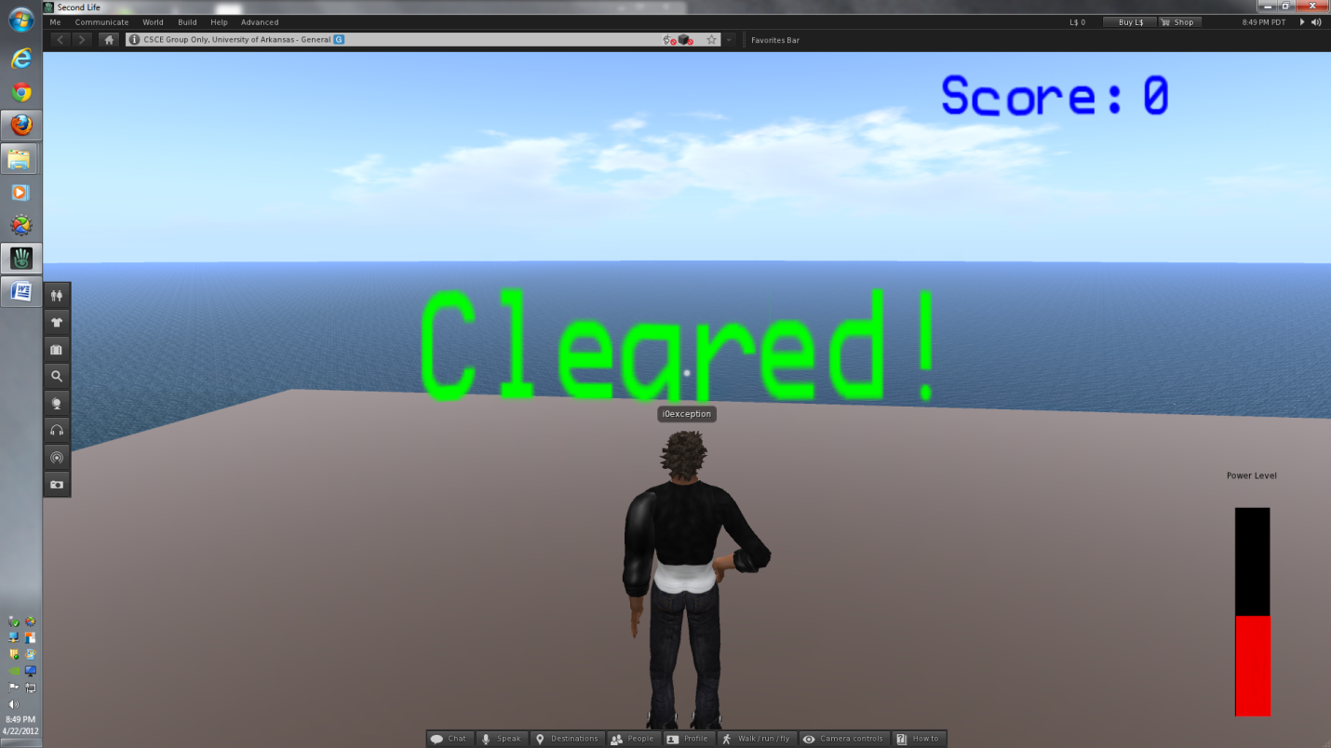

**Power Level:**

Located on the bottom right of the screen, the power level shows the user the current power level of the cannon object in SecondLife. The red bar denotes the power level; full red bar means a power of maximum 200m/s while an empty bar indicates a 0 m/s. This is automatically updated as the power level change.

Debugging Command:

Send "power #" to channel 7888.

Example: "/7888 power 40" changes the indicator to power level of 40.

**Score/ScoreText:**

Located at the top right of the screen, the score HUD shows the current of user for the current sessions of the angry prims game. This automatically changes as shots are fired and objects are destroyed on the field. It is capable of indicating negative and positive values. The current setup allows a maximum score of 6 digits to show correctly. Higher scores require minimal shifting of the text to the left to show more digits. The maximum allowed digit is currently 20. The scoring system is all done on the server. This means that the score HUD only receives message and does not control any aspect of the game condition. Model-View-Controller software design was allowed for the HUD.

Debugging Command:

Send "score #" to channel 7888.

Example: "/7888 score 3000" changes the indicator to a score of 3000.

**GameMessage:**

The game message HUD is located on the center of the screen to indicate the current status of the game condition. There are currently two available messages to the user. There is an infinite amount of message allowed.

Current Messages:

Win Condition: "Cleared!"

Losing Condition: "Failed!"

At the beginning of game session, the game message HUD is transparent to the user. The message changes only after receiving a command from the game controller.

Debugging Command:

Send "cleared #" to channel 7888.

0 : command evokes the losing condition.

1: command evokes the winning condition.

-1 : clears the GameMessage HUD. No message is seen.

Example: "/7888 cleared 1" changes the indicator to a winning condition.